

Subscribe to DeepL Pro to edit this document.  
Visit [www.DeepL.com/pro](https://www.deepl.com/pro?cta=edit-document) for more information.

Document Project

rda-902 Document Project

Contents

1. Purpose 2

2. Technical-functional description 2

2.1 Definition of entities 2

2.2 Description of features for each entity 2

2.2.1 User 2

2.2.2 Institute 3

2.2.3 Project 3

2.2.4 Document 3

2.3 DB definition 4

2.4 Description of functions 5

2.5 Graphical user interface models 6

# Purpose

This document defines the implementation specifications of the new "Document Project" program. This document defines the program management entities and ogets, entity characteristics, functions and GUI, anchè the data model (DB).

# Technical-functional description

"Document Project" is a product that allows uploading different documents to a server and attaching them to different institutions. The uploaded documents will be available for bank operators to download. In the GUI, documents will be grouped on the following attributes: institution (bank), date (year and month), additional property. There will also be a module visible only to program administrators in which it will be possible to manage all users and institutions.

## Definition of entities

The following main program management objects have been relevant:

* User - the entity that describes the program utiliser
* Institute - the entity that describes the banks to which various documents are attached
* Document - the entity representing the basic object that is managed in the program
* Project - the entity representing a project, additional feature for documents of a certain MACRO type

## Description of features for each entity

## User

The user represents the utilisator of the program. There are 3 user groups:

* Administrator - manages program users and institutions
* Cedacri operator - manages documents, does document uploading
* Operator Banking - attached only to one institution, can download only documents attached to the same institution

The user as a management object is described by the following attributes:

* Identifier - unique identifier, numeric
* User name - the user name (username) alphanumeric, maximum (32)
* First Name, Last Name, Patronymic **???**
* Password - the password of the user with which he/she logs into the program, alphanumeric
* Email address - the address of the email
* Type - group the user belongs to (administrator, Ced operator, bank operator), the same user can be included in all three groups **???**
* Institution - the bank to which the user is attached (is valid only for users who are part of the *banking operators* group)
* Enablement - a flag that shows whether the user is enabled or disabled in the system

## Institute

The institution represents the bank to which bank operators and documents uploaded into the system will be attached. The bank, as an object of management is described by the following attibutes:

* Identifier - unique identifier, numeric
* Code - unique bank alphanumeric code, alphanumeric, maximum (5) **???**
* Name - bank name, alphanumeric, maximum (...)
* Additional - additional information **???**

## Project

Project represents the entity to which documents that have the MACRO Type = Design are attached (see 3.2.4 Document for details). The project is created by Cedacri operator. It is described by the following attributes:

* Identifier - unique identifier, numeric
* Name - the name of the project, alphanumeric, maximum 255
* Institute - reference to bank with which the project is linked
* User - reference to the user who created the project
* Date from - date from which the project was started
* Date a - date until which the project was started
* Additional information - a brief description of the project, alphanumeric maximum 1000
* Active - flag that shows us whether the project is enabled or not (in case the due date has not arrived yet, but the project already is not a valid one)

## Document

Document represents the basic management object of the system. The document is attached to an institution and uploaded by a Cedacri operator, doppo is available for download to bank operators attached to the same institution. The following document types are provided:

* Service report:
  + Network
  + Security
  + Change
  + Backup
* SLA Report
* Design:
  + Analysis
  + Transition
  + Production
  + Test
  + Monitoring

Document as a management object is described by the following attibutes:

* Identifier - unique dentifier, numeric
* Institute - the institute to which the document was attached, reference to institute
* Operator - the user who uploaded the document, reference to operator
* Project - reference on project to which ul document is attached (valid only for macrotype = DESIGN)
* Name - the name of the file, document, alphanumeric, maximum (260)
* Upload date - date when the document was uploaded into the system
* Document type - document type, reference on one of the values enumerated above
* Path pel save document - complete path where the document is saved. You have to work out an algorithm to save the document (a root/BANK/YEAR/MONTH/DocumentName + Type + something....
* Additional information-some additional information, alphanumeric or text
* Date by grouping - date on the basis of which the document will be grouped in the user's graphical interface **???**

## DB definition

The DB diagram is shown in drawing 3.3.1. The file with the script to create all objects in the DB is located in object 3.3.2.



Des. 3.3.1 The DocumentManagement database diagram.



Object 3.3.2 The file with the script that creates all the tables in the DB with the name DocumentManagement

## Description of functions

**TO COMPLETE.**

## Graphical user interface models

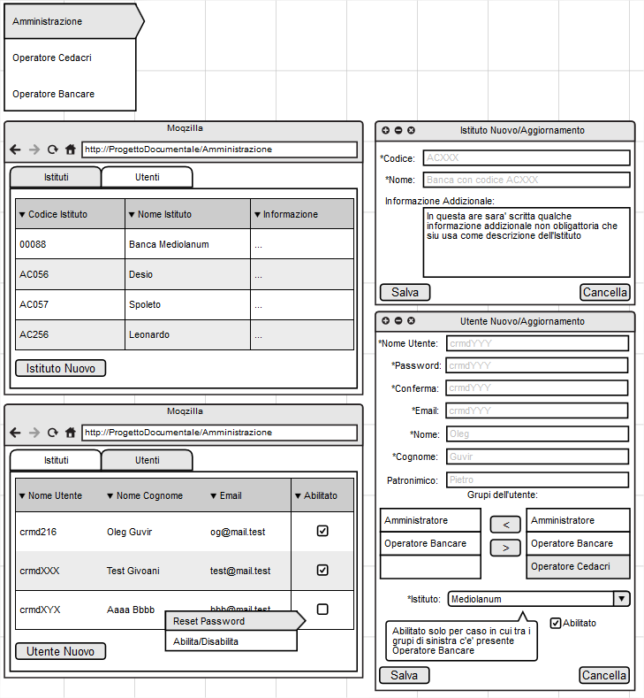

Des. 3.5.1 Graphical user interface for the system administrator.

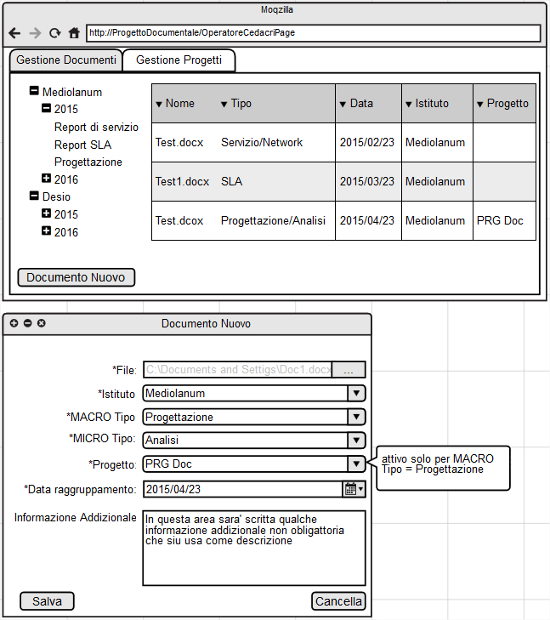

Des. 3.5.2 GUI for Cedacri operator, document management

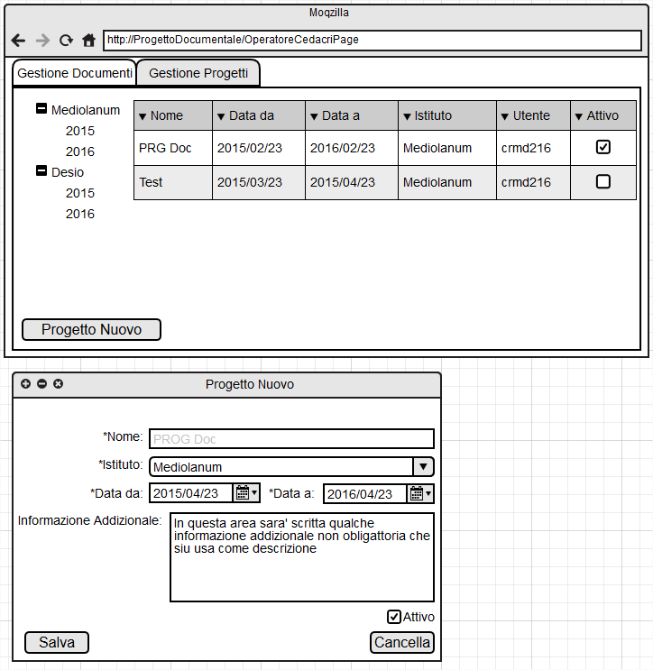

Des. 3.5.3 GUI for Cedacri operator, document management

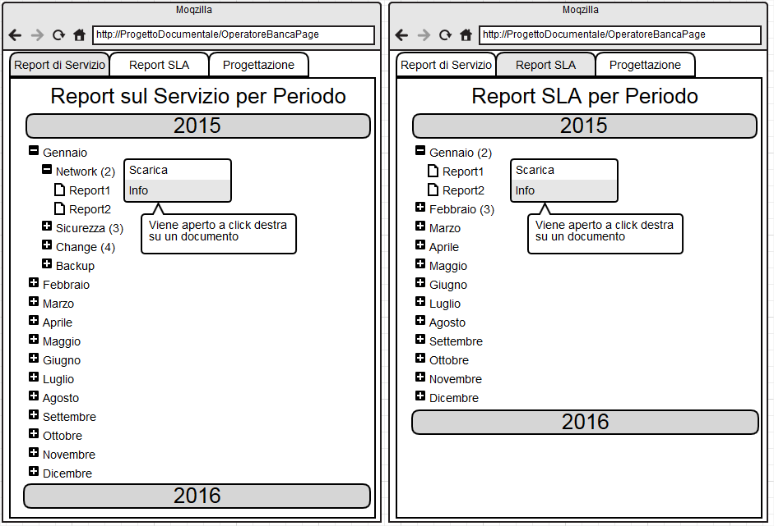

Des. 3.5.4 Graphical interface for the bank operator, Service Report and SLA Report documents.

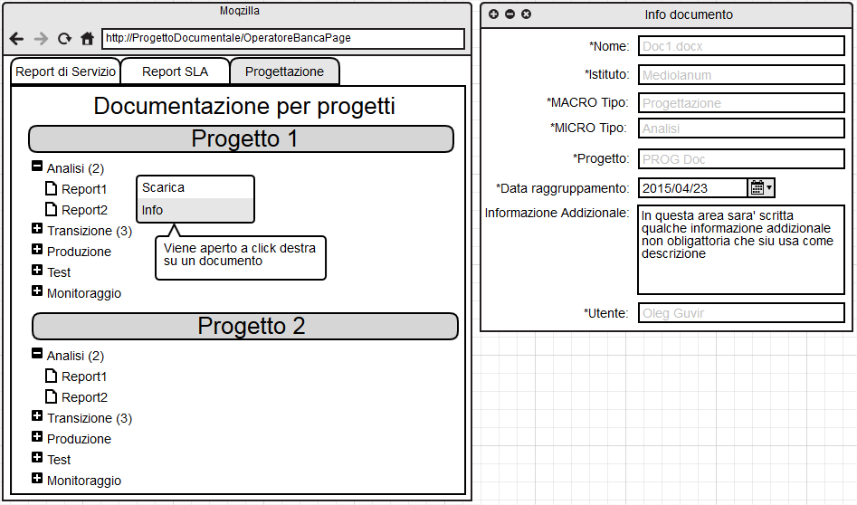

Des. 3.5.5 Graphical interface for the bank operator, documents for projects, and the document details window